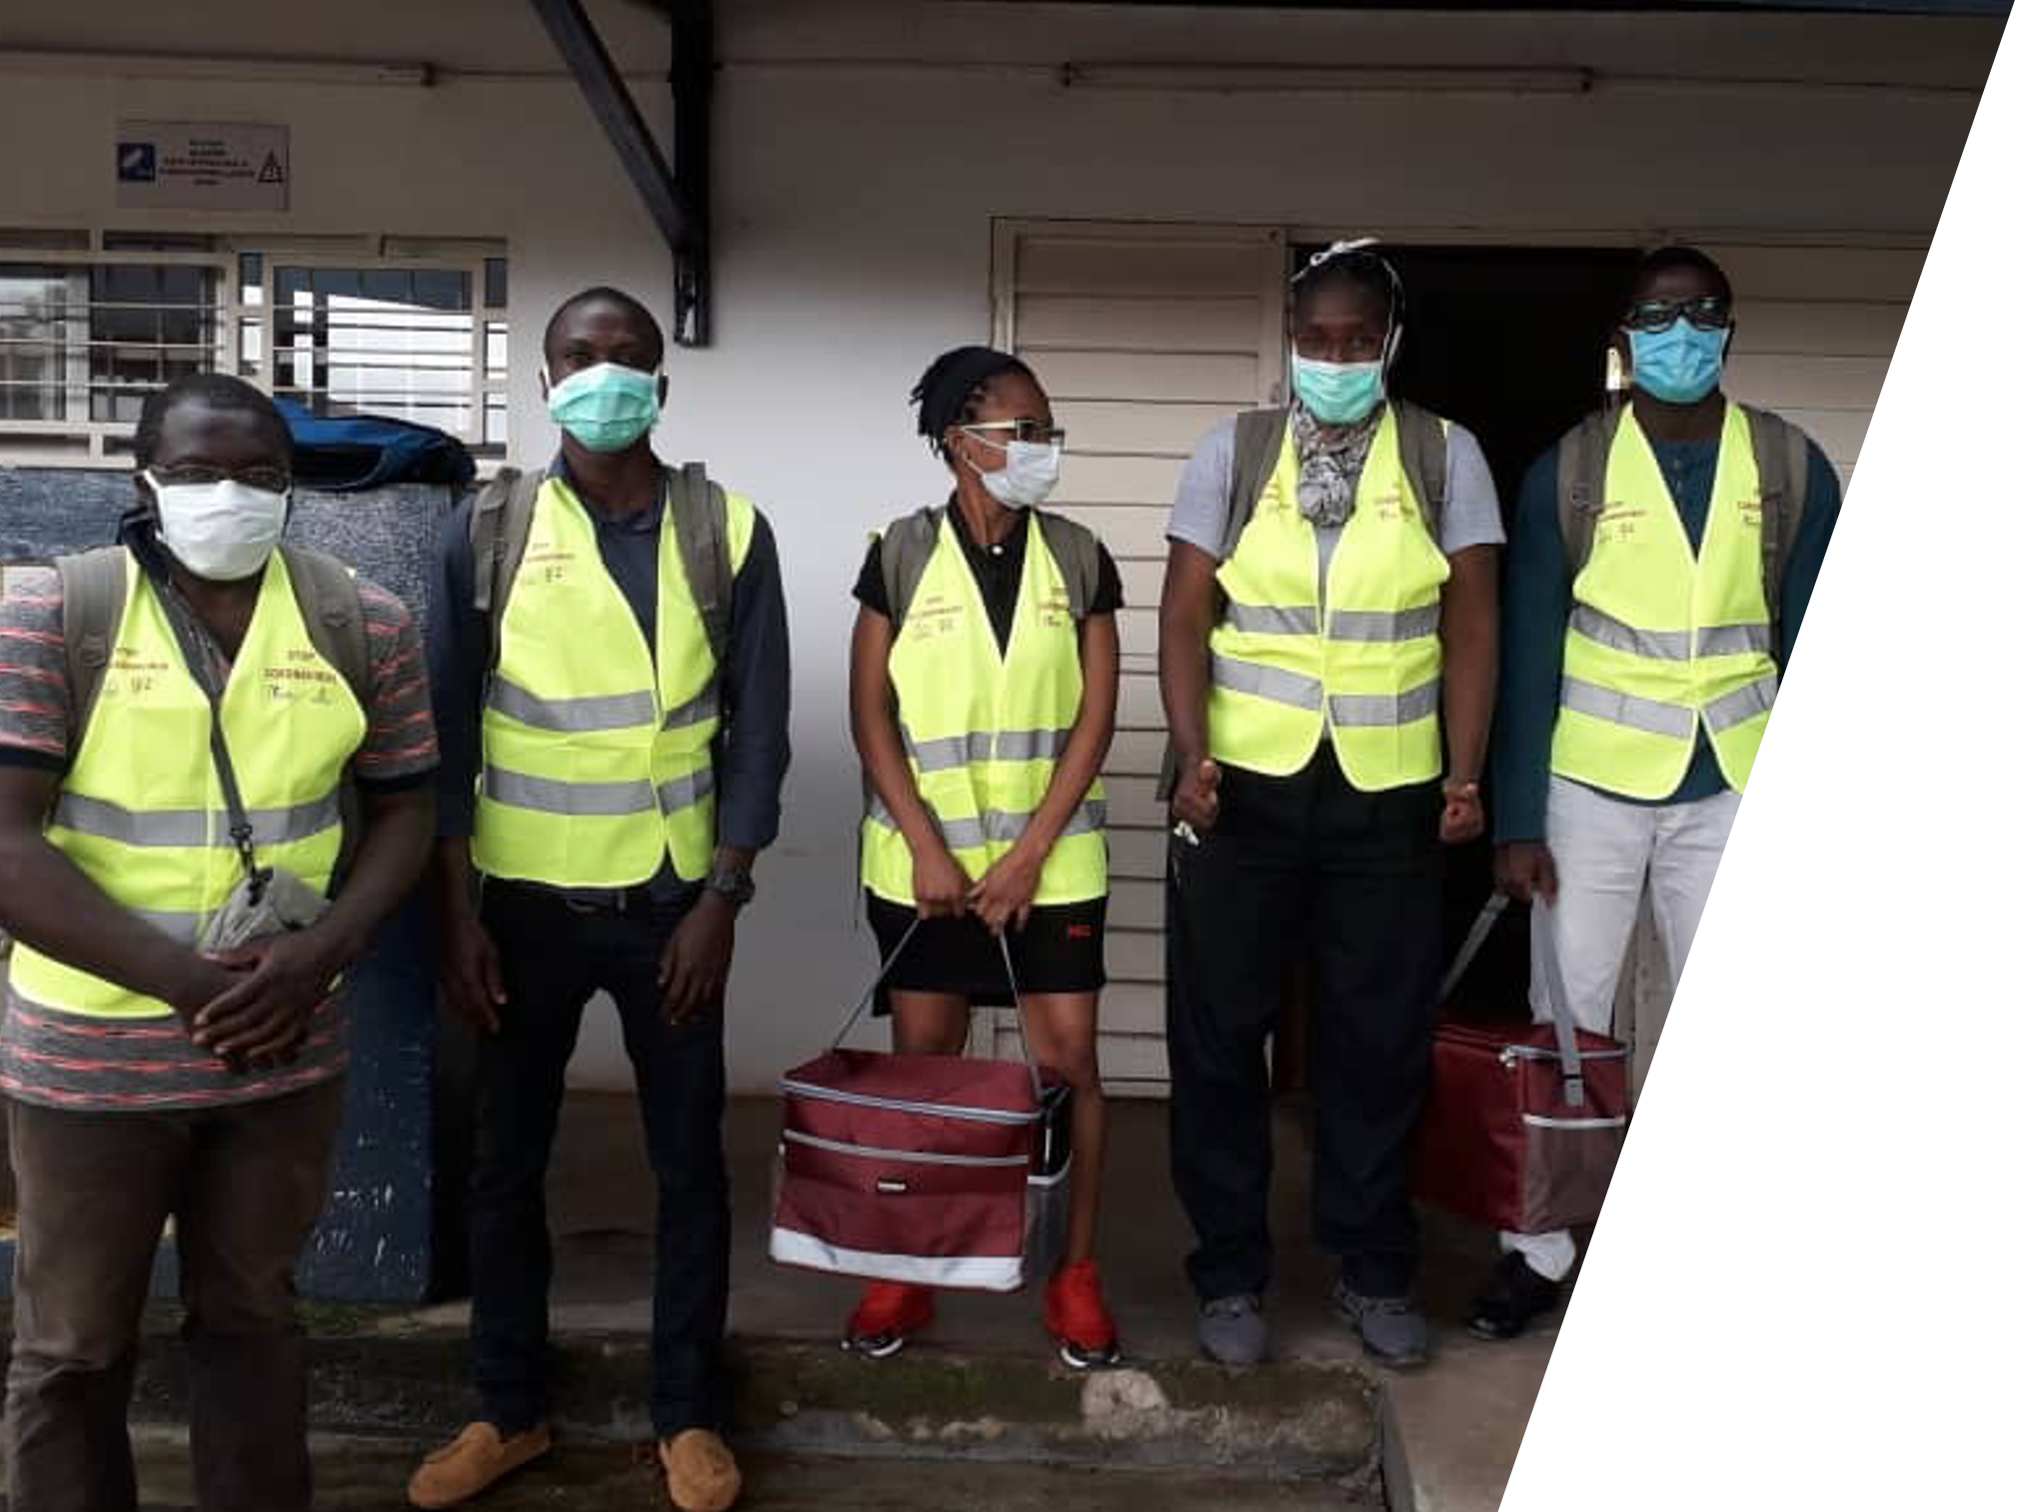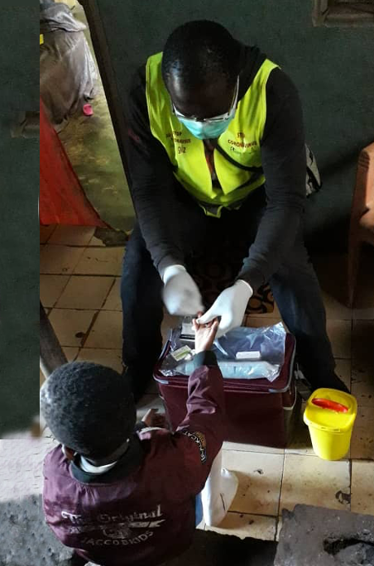

**Supported by:**

ASCRES • CIRES • MINSANTE Cité Verte • CIRCB • GIZ • University of Geneva • Canton Geneva

Supported by:

ASCRES • CIRES • MINSANTE Cité Verte • CIRCB • GIZ

Supported by:

ASCRES • CIRES • MINSANTE Cité Verte • CIRCB • GIZ

Supported by:

ASCRES • CIRES • MINSANTE Cité Verte • CIRCB • GIZ

**EpiCO19 Final Report**

Epidemiological survey and active screening for COVID-19:

Investigating the circulation and impact of SARS-CoV-2 on the population of the health district of Cité Verte in Yaounde

Epidemiological survey and active screening for COVID-19:

Investigating the circulation and impact of SARS-CoV-2 on the population of the health district of Cité Verte in Yaounde

Epidemiological survey and active screening for COVID-19:

Investigating the circulation and effect of SARS-CoV-2 on the population of the health district of Cité Verte in Yaounde

Epidemiological survey and active screening for COVID-19:

Investigating the circulation and impact of SARS-CoV-2 on the population of the health district of Cité Verte in Yaounde

Epidemiological survey and active screening for COVID-19:

Investigating the circulation and impact of SARS-CoV-2 on the population of the health district of Cité Verte in Yaounde

Epidemiological survey and active screening for COVID-19:

Investigating the circulation and impact of SARS-CoV-2 on the population of the health district of Cité Verte in Yaounde

**Feb 04, 2020**

Epidemiological survey and active screening for COVID-19: Investigating the circulation and effect of SARS-CoV-2 on the population of the health district of Cité Verte in Yaounde

|  |  |
| --- | --- |
| **Principal Investigators** | **Affiliation** |
| Dr Laura Ciaffi | **ASCRES** - Association de soutien aux centres de recherches, d'enseignements et de soins  Tél : 00237 694 92 67 86  Mail : [lauraciaffi2002@yahoo.fr](mailto:lauraciaffi2002@yahoo.fr) |
| Dr Franck Wanda | **CIRES** – Centre International de Recherches, d'Enseignements et de Soins  Tél : 00237 699 73 46 89  Mail : [franck.wanda@cires.solutions](mailto:franck.wanda@cires.solutions) |

|  |  |
| --- | --- |
| **Investigators** | **Affiliation** |
| Dr Lucien Mama  District medical Officer | **Ministry of Public health**  District de Sante Cité Verte -Yaounde |
| Dr Joseph Fokam  Virologist | **CIRCB -** Centre International de Reference Chantal Biya pour la recherche sur la prevention et la prise en charge du VIH/SIDA, Yaoundé |
| Dr Eric Comte  Public Health Specialist | **ASCRES** - Association de soutien aux centres de recherches, d'enseignements et de soins |
| Prof. Olivia Keiser  Head of division of Infectious Diseases and Mathematical Modelling | **University of Geneva**, Institute of Global Health |
| Prof. Nicolas Ray  Associate Professor | **University of Geneva,** Institute of Global Health |
| Erol Orel  Scientific Collaborator | **University of Geneva,** Institute of Global Health |
| Kene David Nwosu  Research Assistant | **University of Geneva,** Institute of Global Health |

|  |  |
| --- | --- |
| **Project Staff** | **Role** |
| Eric Mimbe | Data Manager |
| Jeanine Meke | Interviewers’ Team Leader |
| Armel Tassegning | Interviewers’ Team Leader |
| Thomas Eyinga | Interviewer |
| Evelyne Boyomo | Interviewer |
| Assana Gondio A Tiati | Interviewer |
| Yolande Maled | Interviewer |
| Josphine Embolo Manga | Interviewer |
| Michel Ntsama | Interviewer |

|  |  |
| --- | --- |
| **Sponsors** |  |
| P4H Health Financing Network | *Mr Josselin Guillebert director ProPASSaR/GIZ* | *Mme Patricia Ndongo* | |
| GIZ Sector Initiative Universal Health Coverage | |
| GIZ ProPASSaR Cameroon | |
| International Solidarity Service | |
| République et canton de Genève | |

Table of Contents

Summary 4

Background 5

Methods 6

Design 6

Population 6

Sampling 6

Laboratory testing 7

Questionnaire 7

Field work 8

Data management 8

Data analysis 8

Seroprevalence estimation 9

Risk factor analysis 9

Ethical considerations 10

Results and discussion 11

Participation rate 11

Respondent and household characteristics 11

Seroprevalence estimates 13

Risk factors for seropositivity 15

COVID-19 related symptoms 17

Risk factors for symptomatic COVID-19 18

Health-seeking behaviour during the pandemic 19

Determinants of health service utilization during the pandemic 21

Effects of COVID-19 on individuals and households 22

Attitudes towards COVID-19 23

Conclusions 24

Bibliography 25

# Summary

**Rationale**: In many countries the COVID-19 pandemic has led to severe strains on health systems and unprecedented levels of societal disruption. While Sub-Saharan Africa has not been completely spared, the epidemic in this region appears to have been relatively less severe. The reasons for the mitigated impact of COVID-19 in Sub-Saharan Africa are not fully understood, although several hypotheses have been proposed. Explaining the cross-country variance in COVID-19 impact requires, most importantly, a clear assessment of the actual extent of populations’ exposure to the virus and the typical manifestations of infection. We thus surveyed the seroprevalence of anti-SARS-CoV-2 IgM/IgG antibodies, and COVID-19-like symptomaticity, in Cité Verte, an urban district of Yaounde, in central Cameroon.

**Materials and methods**: EPICO 19 is a cross-sectional community-based serosurvey, conducted from October 14 to November 26, 2020, in a densely-populated health district (Cité Verte) of the city of Yaounde, one of the cities most impacted by the COVID-19 epidemic in Cameroon. Households were randomly selected, and inhabitants between 5 and 80 years in each household were surveyed. The Abbott Panbio IgM/IgG SARS-CoV-2 antibody rapid test was used, and a questionnaire on illness symptoms, health-seeking behaviour, and health protective measures was administered. Suspected active COVID-19 cases were tested and managed free of charge following national guidelines. Final seroprevalence estimates were reweighted to the age-sex distribution of the Yaoundé population, and were adjusted for test specificity and sensitivity. The study obtained ethical clearance and administrative authorisation from national institutions and each participant gave informed consent.

**Results**: Out of 255 households visited, 192 (75%) agreed to participate, for a total of 1,007 respondents, of whom 970 consented to an antibody test. Participants were majority women (56.6%), with a median age of 26 years and 11% reported suffering from a chronic health condition. Age-sex-reweighted, test-adjusted IgG seroprevalence was estimated to be 29.2%, with a notable increase with age. Significant risk factors for seropositivity were male sex, obesity and residency in large households. A minority (30%) of antibody seropositive participants reported having had COVID-19 suspect symptoms and these were mainly managed through local and self-prescribed remedies. Fear of infection was the one significant association with health seeking behaviour. Concerning the impact of the pandemic and containment measures on the population, the vast majority (85% of household heads) declared a loss of income since the beginning of the pandemic, with people working in the informal sector being most affected Notably, more than half of respondents reported an increase in stress and pressure in the family environment with a third notifying of having been victims of psychological or physical violence during the pandemic period.

**Conclusion**: SARS-CoV-2 appears to have circulated widely in the city of Yaoundé, affecting at least a third of the population in the *Cité Verte* district. However, more than 60% of those with antibodies reported having no symptoms, confirming the largely asymptomatic nature of infection. The most exposed groups in the community appear to be men, people with obesity, and those living in crowded households.

Disruptions to work and income were widely reported, and many respondents had difficulties in paying for healthcare services due to financial constraints. Social and family activities were also significantly disrupted, leading to situations of conflict, stress, and sometimes violence.

# Background

Coronavirus disease 2019 (COVID-19) is caused by the severe acute respiratory syndrome coronavirus-2 (SARS-CoV-2), which was identified for the first time in China at the end of 2019.1 The virus quickly spread globally, and the World Health Organization declared COVID-19 to be a pandemic on March 11, 2020. As at December 1, 2020, there have been over 67,000,000 notified cases, with over 1,500,000 reported deaths.2

Given the rapid spread of the epidemic in Europe and the Americas, and the handicapped response by countries with the richest health systems, the outlook for less developed countries, and sub-Saharan Africa in particular, seemed dire. High numbers of deaths were expected due to weaknesses in health systems, difficulties in enforcing hygiene measures, and perceived health vulnerabilities of the population.3,4 But the trajectory of the epidemic on the continent appears to have gone against expectation. Despite having over 2,200,200 infections as of December 1,2 Africa remains the least affected region and the mortality rate, even if not well documented, remains lower than expected.4

Multiple hypotheses have been advanced to explain the seemingly mild trajectory of the COVID-19 epidemic in Africa: researchers have pointed to the warm climate conditions across sub-Saharan Africa (apart from South-Africa), the continent’s young population (median age of 19 years), and cross-reactive or non-specific immunity from other infections as possible mitigating factors.4 But an informed explanation of the epidemic trajectory requires, first and foremost, accurate numbers on the actual extent of population infection. And, as has been observed elsewhere,5 the officially reported case counts in Africa may significantly underestimate the extent of the viral propagation.4 In this context, the use of serological antibody tests to detect exposure to SARS-CoV-2 is valuable.

A number of validated SARS-CoV-2 antibody tests now exist on the market,6 and some of these are point-of-care lateral-flow immunoassays, which are affordable, easy to use and provide quick results. These antibody tests offer the opportunity to estimate the degree of population exposure to SARS-CoV-2, and can help inform future surveillance and intervention efforts.5

This report presents the protocol and results of our study using a lateral-flow immunoassay to assess the seroprevalence of anti-SARS-CoV-2 IgG and IgM antibodies in Cité Verte, a district of Yaounde, the capital city of Cameroon.

In addition to examining seroprevalence, our survey also hopes to shed light on the broader impact of the epidemic on the socioeconomic wellbeing of the study population. Soon after its first notified COVID-19 case (on March 6, 2020), Cameroon closed its borders and implemented significant social and physical distancing measures, including mandatory bar closures after 6 PM, limitations on public transport occupancy, bans on gatherings of more than 50 people, and the closing of in-person schools.7 Similar measures were taken in other African countries to curb the spread of infections and to mitigate the socio-economic impact of the pandemic in these resource-limited settings.

The effects of COVID-19 barrier measures on the wellbeing of the Cameroonian population have not been well examined. Studies in other contexts have noted that during the pandemic period, access to routine health care services has been disrupted. Thus, together with the SARS-CoV-2 antibody survey, we also designed and implemented a survey to assess whether such disruptions were common in the studied population.

# Methods

The EpiCO 19 study is a community-based survey to estimate the circulation and the impact of SARS-CoV-2 and the COVID-19 pandemic on a district in Yaounde, which is one of the townships most affected by COVID-19 in Cameroon.

## Design

EpiCO 19 is a cross-sectional, clinico-epidemiological and socio-economic study.

## Population

The *Cité Verte* district, located in the Mfoundi department of the Center Region of Cameroon, covers a surface area of 19 square kilometresin the administrative area of Yaounde II. The total estimated population is 432,858, of which the majority are young. It is located in the oldest part of the city of Yaounde and residents are from several different regions of Cameroon.

Households are of two major types: 60% are permanent, built with standard building materials, while 40% are temporary structures. Some neighbourhoods, notably *Tsinga* and *Cité Verte* (the Cité Verte neighbourhood of the Cité Verte district), are better equipped in services and roads than others.

*Cité Verte* is divided into nine health zones with a total of 63 health structures, of which eight are public and three are run by private, faith-based providers. In each of the health areas there is a referent health structure and a number of community health workers supporting public health activities that are carried out by the Ministry of health or other partners in the community. These personnel have been essential for the study implementation by facilitating access to the population.

## Sampling

The following formula was used to calculate the sample size of the study:

$$n=\frac{Z^{2}\left(p\left(1-p\right)\right)}{d^{2}}$$

Where n = the minimum sample size required, Z = the value of the standard normal distribution at the confidence level of 95%, p = expected prevalence or proportion, and d = precision.

With this formula, a level of confidence of 95% (Z=1.96), a precision of 5%, and an estimated prevalence of anti-SARS-CoV-2 of 20% in the general population, a minimum of 245 people was calculated to be sufficient, but the sample was increased to 1000 people to provide for improved precision and better representation of different parts of the community.

Households were randomly selected from a pre-processed set of all buildings in the *Cité Verte* district. The building footprint came from the global participatory mapping project Open Street Map, and was initially filtered to exclude those buildings not informed as residential. A standard replacement procedure was used when the selected buildings were not residential.

Households, which were the sampling unit of the study, were defined as a group of people living in the same residence and sharing the kitchen.

In each household, all individuals between 5 and 80 years were included if they: (a) were living in the selected household, (b) had been present in the household for at least 14 days, and (c) could give written informed consent (or had an adult guardian who could give consent). People with severe psychiatric illness or anyone from a non-eligible household were not considered for inclusion as study participants.

## Laboratory testing

The EpiCO19 study used the Abbott Panbio™ COVID-19 IgG/IGM Rapid Test Device, an immunochromatographic test for the qualitative detection of IgG and IgM antibodies directed against SARS-CoV-2. The manufacturer-estimated sensitivity and specificity of the test are 95.8% and 94% respectively.

The serological tests were performed on capillary blood collected from a finger prick of each consenting participant. All waste material was eliminated following standard safety procedures by the study team. During sample collection all biosafety precautions were followed. The person in charge of swab collection was provided with full personal protection equipment (apron, gloves, face shield and FFP2 mask).

Additional steps were taken when active COVID-19 was suspected as per the WHO COVID-19 criteria for the definition of symptomatic cases, updated as at August 2020. The national algorithm for further testing was applied to these suspected cases. Briefly, a nasopharyngeal swab was taken and a rapid antigen test was performed. If the result of the antigen test was negative, the swab was sent to the reference virology laboratory of the Chantal BIYA International Reference centre (CIRCB) for the viral RNA extraction, followed by real-time PCR for the amplification and detection of SARS-CoV-2. This PCR test was also proposed to all participants with a positive IgM result from the serological testing, as IgM response may serve as a surrogate of an acute or active infection.

As per the national strategy for molecular diagnosis of SARS-CoV-2, real time PCR tests were carried out at the virology laboratory of the CIRCB, which is the reference laboratory for COVID 19 in the *Cité Verte* District, following standard procedures both for biosafety and in vitro molecular diagnostics. Briefly, CIRCB is a well-equipped centre with biosafety level-2 cabinets in place, real-time and conventional PCR work stations, a sequencing core facility with two genetic analysers, and the center participates in external quality assurance (EQA) and proficiency testing (PT) programs with the WHO and ASLM for SARS-CoV-2 molecular diagnosis.

## Questionnaire

A questionnaire was created with KoboKollect©, a free software for epidemiological surveys.

The first few sections of the questionnaire focused on household composition, household income and recent deaths within the household. Then individual information about each survey respondent was collected. These sections included questions about the respondents’

* experience of symptoms compatible with COVID-19;
* health-seeking behaviour during the pandemic;
* financing of healthcare during the pandemic;
* attitudes towards COVID-19; and
* respect of hygiene and physical distancing recommendations;

among others.

The questionnaire was field tested and modified following the feedback of the tests in the field.

## Field work

All the interviewers were trained over three days on good clinical practices and health research ethics, as well as the specific details and procedures of the study protocol.

In the first two weeks of study implementation, a part of the team conducted the geo-localisation of the majority of the households, supported by the healthcare workers of each health area.

To increase responsiveness to the survey, awareness talks were carried out one day, or a few hours, before the interviewers’ visit. On the interview days, study teams visited each household to interview the residents immediately or to arrange an appointment for a future interview.

Once residents were gathered, the study was presented and the informed consent form was given out to be signed. For anyone below 21 years, a signature was requested from the parent or legal guardian, including an assent provided by anyone above 15 years. The survey questionnaire was then administered to each consenting household member.

In a safe, quiet and private space, the material for the tests was set up and all the procedures for the test were respected. A picture of the test was taken and a paper result was handed out to the participant with the explanation of the result interpretation. When any case of active COVID-19 was suspected (positive IgM antibody test or COVID-19 related symptoms), a nasopharyngeal swab was collected, information about preventive measures was provided to the respective individual, by the study team, and the surveillance system of the health district was alerted.

## Data management

Once the questionnaire was completed, it was uploaded to a secure server. Data were regularly monitored for completeness and coherence, and for agreement between the responses of different members of each household.

## Data analysis

### Seroprevalence estimation

Seroprevalence values were weighted within each age or sex stratum to match the age-sex distribution of the Yaounde population, as sourced from the 2018 Cameroon demographic and health survey (DHS)8.

To account for test performance, the Rogan-Gladen formula was used to adjust IgG seroprevalence estimates.9 We then used the sensitivity estimate provided by the validation study of the Abbott test (Batra *et al*), which found a sensitivity of 91.5% (i.e. 75 accurate diagnoses out of 82 samples) when applied on sera collected from hospitalised COVID-19 patients 14 – 56 days post symptom onset.10 We measured the analytical specificity by applying the test on a panel of 246 pre-pandemic (2017) samples from individuals living in Yaounde. The IgG test accurately diagnosed 230 of 246 samples (93.5% specificity), which is similar to the specificity (i.e. 94%) reported by the test manufacturer.

We did not apply test performance corrections to the IgM prevalence estimates: because IgM antibodies decline rapidly, becoming undetectable a few weeks after infection,11 a steady estimate of sensitivity for the IgM test cannot be obtained, since sensitivity estimates will vary very widely with time since infection. As we made no assumptions about the time of infection of those who tested positive for antibodies, we were unable to conclude about the contextual sensitivity of this test. The same caveat also applies to the IgG test, but the slower decline of IgG antibodies means the assumption of stable test performance is more plausible for the IgG biomarker.

Confidence intervals for test-adjusted estimates were Lang-Reiczigel intervals,12 which take into account the sample size of the antibody test validation study. Other confidence intervals for prevalences were Wilson score intervals.

### Risk factor analysis

For seropositivity risk factor analysis, we used logistic models with household random effects to account for within-household clustering. In the logistic models, the following prospective risk factors were analysed: sex, age, education, body mass index (BMI) group, occupation, contact with an international traveller since March 1st, contact with a suspected or confirmed COVID case since March 1st, presence of comorbidities (combining hypertension, respiratory illness, diabetes, tuberculosis, HIV, cardiovascular illness and “other illnesses” which were not explicitly listed in questionnaire), whether or not the respondent is the breadwinner of the household, adherence to social/physical distancing rules, location of the household (one of nine health zones), number of household members, and whether or not there were children in the household. Each variable was first analysed in a univariate model. Then variables with p < 0.10 for at least one factor level were entered into the multivariable analysis. All such variables are shown in the regression tables.

We used a simple logistic regression model to analyse risk factors for symptomatic COVID-19 cases among those who were seropositive. Respondents with symptomatic COVID-19 were considered as those who tested positive for IgG or IgM antibodies and who experienced COVID-19 suspected symptoms since March 1st, 2020. COVID-suspect symptoms were defined, following WHO guidelines13, as:

* anosmia OR ageusia; or
* cough AND fever; or
* at least THREE of cough, fever, fatigue, headache, muscle pain, sore throat, runny/stuffy nose, shortness of breath / difficulties in breathing, nausea, diarrhoea.

Based on clinical justification, we identified the following as potential risk factors for symptomatic COVID-19: sex, age, BMI group, pregnancy, smoking habit, hypertension, respiratory illness and diabetes. We used the same procedure as with the seropositivity regressions to select for potential significant variables.

To analyse the determinants of formal healthcare utilization, we also used logistic models with household random effects. The following prospective risk factors were analysed: sex, age, fear of stigma from COVID-19 diagnosis, income decrease during the pandemic, stated difficulty in paying for medical costs, stated difficulty in traveling to healthcare centres, and stated belief that healthcare centres are dangerous due to COVID-19. We repeated the same procedure as above to select for potential significant variables.

For all regression analyses, age and sex were included as controls in all models, even when their effects were not significant in the univariate analysis.

Some factors analysed were individual-level variables, and others were household-level variables. The household-level variables were based on the answers of household “representatives”. The household representative was taken to be:

* the first interviewed adult (18 + ) who self-identified as the household head (“*Chef du menage*”); and, if no head was present,
* the first interviewed adult.

Data were processed and analysed using R version 4.0.2 and RStudio. Key packages used included *lme4* for model fitting14, *DescTools* for the calculation of binomial confidence intervals15 and the *tidyverse* packages16 for data manipulation.

## Ethical considerations

The study protocol obtained an ethical clearance and an administrative authorization of the Ministry of Public Health of Cameroon. Every adult participant (21 years or above) signed an informed consent. For minors, a person with parental authority was asked to sign the proxy-consent form and, if the age was equal to or above 15 years, an assent was also requested. Questionnaires were coded and names of participants were recorded in a confidential list available only to the study team. Before starting the study, all the team members were trained on health research ethics, good clinical practices and the study protocol and procedures. Laboratory results were provided free of charge, and PCR-positive cases were referred for appropriate management as per the national guidelines for COVID-19 management in Cameroon.

# Results and discussion

## Participation rate

Out of 255 households visited, 192 (75%) agreed to participate, for a total of 1,007 respondents.

Of the 192 included households, 128 were the originally sampled by the random method, while the remaining 64 (33%) were replaced through standard procedures because the identified buildings were non-residential.

Table : Households and individuals expected and included in the study.

|  |  |  |  |  |  |
| --- | --- | --- | --- | --- | --- |
|  | Inhabitants | N of household sampled | N of inclusions expected | N of households included | N of people included |
| Briqueterie | 52 850 | 31 | 124 | 24 (77%) | 109 (88%) |
| Carrière | 104 785 | 61 | 244 | 45 (73%) | 240 (98%) |
| Cité verte | 38 832 | 22 | 88 | 24 (109%) | 88 (100%) |
| Messa | 18 899 | 11 | 44 | 9 (81%) | 48 (109%) |
| Mokolo | 46 960 | 27 | 108 | 17 (63%) | 96 (89%) |
| Nkomkana | 41 953 | 24 | 96 | 15 (62%) | 81 (84%) |
| Tsinga | 35 349 | 20 | 80 | 16 (80%) | 83 (103%) |
| Tsinga Oliga | 37 572 | 22 | 88 | 14 (63%) | 71 (80%) |
| Ekoudou | 55 659 | 32 | 128 | 28 (87%) | 191 (149%) |
| Total | **432 859** | **250** | **1,000** | **192** | **1,007** |

All the health areas of the district were surveyed, but participation varied between the neighbourhoods (Table 1). All participants were to be tested for SARS-CoV2-antibodies, but in 35 cases (3%), some members of the household, in spite of responding to the questionnaire, refused the test.

## Respondent and household characteristics

Participants had a median age of 26 (IQR 14-38) years and 570 (56.6%) were women. The demographic characteristics of respondents are summarized in Table 2.

Households had a median of 5 adult (15 years or above) and 2 children inhabitants. In the majority (92%) of the visited households, the head of the family was surveyed and in 136 households (70.8%), we had access to the person providing the main source of income. This was most often the father (55.7% of households) or the mother (36.5%).

Household members were most commonly students (39.5%), working “small jobs” (21%) or working as traders (12.4%). This underscores the high percentage of households declaring irregular and informal sources of income (41%). Interestingly, despite only 5.7% of respondents reported regular remunerated jobs, formal regular income was the main source of revenues for 23% of the households, showing the possible contribution of other family members.

Only six households reported a prior positive COVID-19 test among their members, but 67 (7%) respondents reported having been tested for SARS-CoV-2 before, with nearly half of these as part of governmental massive screening campaigns.

One hundred eight participants (11%) reported suffering from a chronic condition, mainly hypertension (34%), respiratory conditions (16%) or diabetes (10%). With a mean BMI of 27.3 (versus 23.2 for men), women showed a higher frequency of overweight. Only 2 respondents reported HIV infection.

Table : Sociodemographic characteristics of the final sample

|  |  |  |  |
| --- | --- | --- | --- |
| Characteristic | Female | Male | Total |
| **N** | 570 | 437 | 1007 |
| Num. household heads | 77 | 101 | 178 |
| Mean Age (SD) | 29.6 (17.4) | 28.5 (17.6) | 29.1 (17.5) |
| Mean BMI (SD) | 27.3 (26.7) | 23.2 (6.26) | 25.5 (20.6) |
| **Age groups, n (% of sex in each group)** | | | |
| 5-15 | 137 (24%) | 128 (29.3%) | 265 (26.3%) |
| 16-29 | 186 (32.6%) | 136 (31.1%) | 322 (32%) |
| 30-45 | 140 (24.6%) | 89 (20.4%) | 229 (22.7%) |
| 46-65 | 79 (13.9%) | 66 (15.1%) | 145 (14.4%) |
| >65 | 28 (4.9%) | 18 (4.1%) | 46 (4.6%) |
| **Education Level, n (% of sex in each group)** | | | |
| Secondary | 258 (45.3%) | 184 (42.1%) | 442 (43.9%) |
| Primary | 191 (33.5%) | 137 (31.4%) | 328 (32.6%) |
| University | 76 (13.3%) | 81 (18.5%) | 157 (15.6%) |
| No formal instruction | 35 (6.1%) | 18 (4.1%) | 53 (5.3%) |
| Doctorate | 7 (1.2%) | 13 (3%) | 20 (2%) |
| Other | 3 (0.5%) | 4 (0.9%) | 7 (0.7%) |
| **Profession, n (% of sex in each group)** | | | |
| Student | 216 (36.5%) | 202 (43.3%) | 418 (39.5%) |
| Small jobs | 86 (14.5%) | 136 (29.1%) | 222 (21%) |
| Business/Trade | 81 (13.7%) | 50 (10.7%) | 131 (12.4%) |
| Housewife | 74 (12.5%) | 0 (0%) | 74 (7%) |
| Unemployed | 52 (8.8%) | 21 (4.5%) | 73 (6.9%) |
| Salaried worker | 38 (6.4%) | 22 (4.7%) | 60 (5.7%) |
| Retired | 18 (3%) | 17 (3.6%) | 35 (3.3%) |
| Other | 17 (2.9%) | 15 (3.2%) | 32 (3%) |
| Farmer | 10 (1.7%) | 4 (0.9%) | 14 (1.3%) |

## 

## Seroprevalence estimates

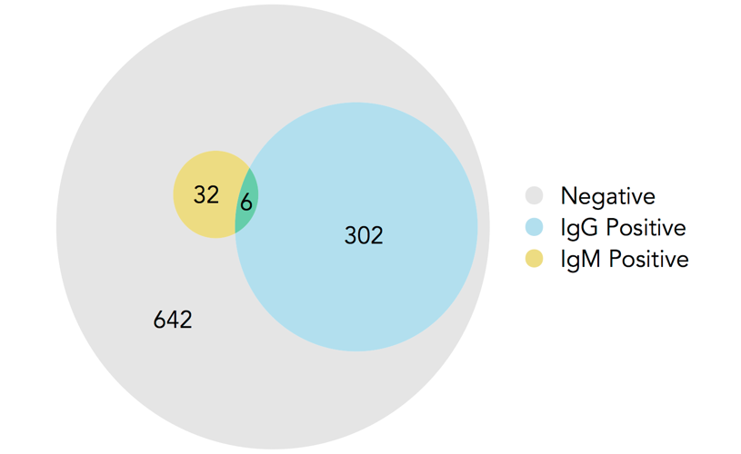

Of the 970 respondents tested for IgG and IgM antibodies, 340 (35.1%) were seropositive for at least one of the antibodies (Figure 1). IgM seropositivity was quite low, and the overlap between IgG and IgM seropositivity was minimal; of note, among the 32 individuals who were IgM positive, only 6 were also IgG positive.

Following WHO diagnostic criteria, 21 suspect cases were identified, and nasopharyngeal swabs were collected for PCR testing. Only one of the 21 RNA PCR tests was positive.

Figure 1: Seropositivity of respondents by antibody test.

Figure 2 shows IgG antibody seroprevalence in each age-sex stratum. Seroprevalence is higher in men, and increases with age. The highest values were seen in men above 65, where the seropositivity was 50%, although the sample size for that group is small (reflecting the population demography).



Figure 2: IgG seropositivity in each age-sex stratum.

Tables 3 and 4 show the seroprevalence adjustments for the age-sex distribution of the Yaounde population and for diagnostic test performance. Since women were oversampled as compared to their proportion in the general population (56.6% of sample was female), and women also showed a lower seroprevalence, the crude estimates were downwardly biased. Thus, population weighting increased the overall estimate of seropositivity in nearly all age categories for both the IgG and IgM assays. Adjustments for specificity and sensitivity also increased the estimates slightly.

For IgG antibodies, overall seropositivity is 29.2%, with an apparent increasing trend with older age (Table 3)

|  |  |  |  |  |  |
| --- | --- | --- | --- | --- | --- |
|  | Sample size, n | Seropos., n | Seroprevalence (95% Confidence Interval) | | |
|  |  |  | **Crude** | **Population- weighted** | **Population-weighted, test-adjusted** |
| Total | 971 | 302 | 31.1% (28.3 - 34.1) | 31.3% (28.4 - 34.3) | 29.2% (24.3 - 34.1) |
| Female | 549 | 154 | 28.1% (24.5 - 32.0) | 28.0% (24.4 - 31.9) | 25.3% (20.0 - 31.2) |
| Male | 422 | 148 | 35.1% (30.7 - 39.7) | 34.6% (30.2 - 39.3) | 33.1% (27.6 - 40.5) |
| 5 – 14 | 241 | 69 | 28.6% (23.3 - 34.6) | 28.7% (23.3 - 34.7) | 30.8% (22.9 - 39.5) |
| 15 - 29 | 325 | 98 | 30.2% (25.4 - 35.4) | 30.7% (25.9 - 35.9) | 26.1% (18.9 - 34.1) |
| 30 - 44 | 212 | 69 | 32.5% (26.6 - 39.1) | 32.7% (26.7 - 39.3) | 28.5% (21.4 - 35.1) |
| 45 - 64 | 153 | 51 | 33.3% (26.4 - 41.1) | 34.1% (27.0 - 41.9) | 32.5% (22.8 - 41.8) |
| 65 + | 40 | 15 | 37.5% (24.2 - 53.0) | 39.4% (25.8 - 54.8) | 38.7% (20.5 - 55.8) |

Table : Population-weighted and test-adjusted seroprevalence estimates for anti-SARS-CoV-2 IgG antibodies

Only 3.4% (2.43-4.8) IgM seropositivity rate was reported, indicating a very low prevalence of IgM (<5%) in the study population, apart from those aged 65 and above where a substantial increase in the seropositivity rate is observed (Table 4). The limited sample size in the last age range, though reflecting the normal population demography, limits the statistical significance of this value.

Table : Population-weighted seroprevalence estimates for anti-SARS-CoV-2 IgM antibodies

|  |  |  |  |  |
| --- | --- | --- | --- | --- |
|  | Sample size, n | Seropos., n | Seroprevalence (95% Confidence Interval) | |
|  |  |  | **Crude** | **Population- weighted** |
| Total | 953 | 32 | 3.4% (2.39 - 4.7) | 3.4% (2.43 - 4.8) |
| Female | 549 | 17 | 3.1% (1.94 - 4.9) | 3.0% (1.90 - 4.8) |
| Male | 404 | 15 | 3.7% (2.26 - 6.0) | 3.8% (2.32 - 6.1) |
| 5 - 14 | 241 | 5 | 2.1% (0.89 - 4.8) | 2.1% (0.89 - 4.8) |
| 15 - 29 | 325 | 12 | 3.7% (2.12 - 6.3) | 3.6% (2.07 - 6.2) |
| 30 - 44 | 211 | 7 | 3.3% (1.62 - 6.7) | 3.9% (2.02 - 7.5) |
| 45 - 64 | 152 | 6 | 3.9% (1.82 - 8.3) | 4.1% (1.94 - 8.6) |
| 65 + | 24 | 2 | 8.3% (2.32 - 25.8) | 8.3% (2.32 - 25.8) |

These seropositivity estimates seen here are in line with observed values in other regions. Many countries have now conducted large seroprevalence studies in the general and specific populations, and seropositivity has ranged from as low as 3% to more than half of those studied 17-21. In the African context, a few studies have been reported. A survey in Kenya among blood donors found a global adjusted prevalence of 4.3% very early in the epidemic.22 Another report in Niger State, Nigeria (data not yet published) reported a prevalence of 25.4%.23

Notably, there is evidence of pre-existing reaction to SARS-CoV-2 antibody testing in African populations: 23.7% (32/135) of pre-pandemic samples from a study in Gabon (a neighbouring country to Cameroon) were found to have humoral cross-reactivity to SARS-CoV-2.24 Thus, adjusting for test specificity, as we have done here, is crucial to arrive at accurate findings about population exposure to SARS-CoV-2

It is important to note that because anti-SARS-CoV-2 immunoglobulins wane over time (one study has reported a 90% decline in levels 3 months from exposure)25, antibody seroprevalence is not a perfect proxy for past infection with the virus.

Finally, the seroprevalence results here should be interpreted with some caution, since our study was not able to validate the test sensitivity on local PCR-positive sera, relying instead on a validation study from a European population25-27

## Risk factors for seropositivity

Variables that were associated with SARS-CoV-2 seropositivity in univariable analyses included sex, educational level, BMI group, contact with an international traveler, contact with a suspected or confirmed COVID case, health zone, and number of household members (Table 5). Age, sex, and any variables where a p-value below 0.1 was observed, were carried over into the multivariate analysis. The results are shown in the last two columns of Table 5. These are largely in line with the findings from the univariate analysis.

Table 5: Risk factor analysis for seropositivity among all participants tested for antibodies. n = 965



OR: Odds ratio. Asterisks indicate significance at a 0.05 alpha level. 41 individuals (4%) were dropped due to variable missingness. Recent contact indicates contact since March 1st, 2020. A “COVID-19 case“ is a confirmed *or* suspected case. Variables that were not significant at a 0.10 alpha level, and which were not controlled for in the multivariate regression include occupation, presence of comorbidities, breadwinner status, adherence to social distancing rules and presence of children in the household.

Therefore, being of male sex, being obese (as defined by a BMI >30), and having five or more household members, are the three independent factors related to anti-SARS-CoV-2 IgG seropositivity. Evidence-based interventions for epidemiological surveillance may choose to focus on these individuals within the communities.

Figure 3 shows distribution of positive serology in the different areas of *Cité Verte* district. This distribution may be partly explained by household size. The figure makes clear that the zone with the smallest households, Cité Verte (mean size 5.5 residents), is also the zone with the lowest prevalence. Therefore, spread within the household or living environment is a driving factor for exposure to SARS-CoV-2 in the Cameroonian community.

## 

Figure 3: Geographic variation in seroprevalence levels.

Map fill colour indicates overall SARS-CoV-2 antibody seroprevalence (IgG or IgM) in each region. Pie charts indicate household size, household location and the proportion of the household that is seropositive. Pie charts in dense regions are dodged to avoid overlap, so locations are not exact. Five households are not shown due to improperly-coded or missing coordinates.

## COVID-19 related symptoms

Three hundred and two respondents (30%) reported having at least one symptom compatible with SARS-CoV-2 infection (frequency of symptoms is reported in Figure 4).

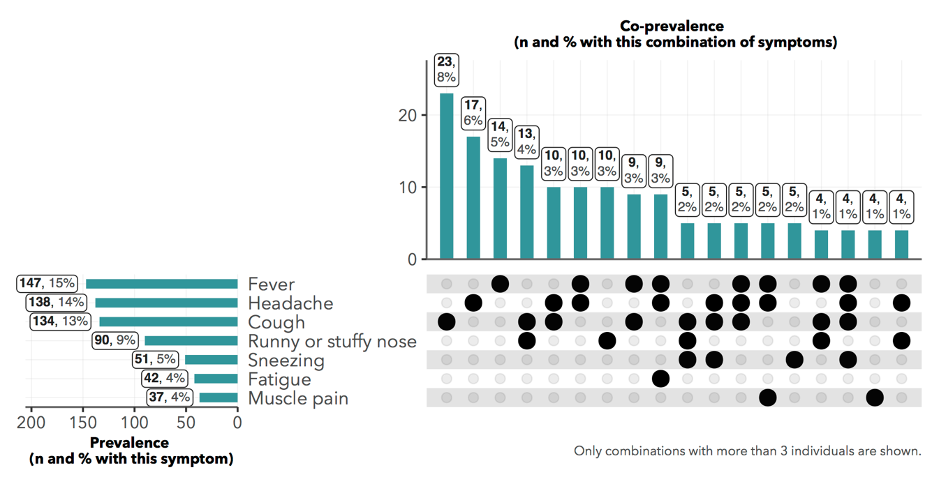

Figure 4: Common reported symptoms. Denominator of percentages is all 1,007 respondents

Among those who tested positive for anti-SARS-CoV-2 IgG, 40% reported at least one symptom. Among these, the most common symptoms reported were fever (18.5%), headache (17.5%), cough (17.9%) and runny/stuffy nose (12.3%), and all four were significantly more common in seropositive than in seronegative individuals (Figure 5). Surprisingly, anosmia or ageusia was only experienced by 4.3% of the seropositive respondents (versus 1.9% of seronegative respondents).

About 83% of respondents with symptoms reported that those symptoms were of moderate severity. But for 44 individuals (15% of those with symptoms) the symptoms were considered severe.

Figure 5: Frequency of symptoms among IgG seropositive and seronegative individuals. 𝝌-square: * p < 0.05

## 

## Risk factors for symptomatic COVID-19

Based on the WHO criteria for COVID-suspect symptoms13, 51 of 328 IgG/IgM seropositive individuals (15.6%) and 64 of 642 seronegative individuals (10%) reported COVID-suspect symptoms, suggesting that the WHO criteria may lack specificity for identifying true COVID-19 symptoms—these might be common symptoms with other respiratory infections or similar pathologies. We analysed a range of variables for association with the presence of symptoms among those with antibody seropositivity. Only smoking status was a significant predictor (Table 6). Smoking is known to alter the respiratory tract and may thus render the host vulnerable to respiratory infections including SARS-CoV-2.

 Table : Risk factor analysis for symptomatic COVID-19 among antibody seropositive respondents (n = 324)

OR: Odds ratio. Asterisks indicate significance at a 0.05 alpha level. 4 individuals (1%) were dropped due to variable missingness. Variables that were not significant at a 0.10 alpha level and were not controlled for in the multivariate regression include BMI group, pregnancy status, the presence of hypertension, of respiratory illness, or of diabetes in the respondent, and the respondent’s smoking status.

## 

## Diagram Description automatically generatedHealth-seeking behaviour during the pandemic

We defined healthcare-needing respondents as those who reported any existing chronic condition or any acute symptom since March 1st, 2020. Based on these criteria, 368 individuals were prospectively in need of health care during the pandemic period (Figure 6)

Among this population of healthcare-needing respondents, 13% visited private clinics and 8% visited general public hospitals and none went to a specialized COVID-19 care centre (Figure 7).

Figure 6: Euler diagram showing the sets of individuals with chronic conditions, acute symptoms and COVID-19-like symptoms

Forty-seven participants reported hospitalization, but only one hospitalization was in relation to COVID-19. Very few individuals reported additional health expenditure due to COVID-19; in cases when this was reported, the additional expenses were mainly for the purchase of personal protective equipment (7 participants paid for transport, 2 for the test and 2 for consultation).

In the group of people with chronic conditions, 14.8% experienced disruption in the continuity of healthcare and 11% had difficulties in accessing their regular treatment. This highlights the significance of COVID-19 on the management of other diseases, and calls for public health measures to revive the affected health services, which include chronic diseases monitoring units (diabetes, hypertension, HIV, etc), outpatient departments, vaccination program, family planning, etc.



Figure 7: Health services used by those who reported any acute symptom/sign or chronic condition.

Among those who reported acute symptoms, only 75 individuals (7%) sought medical attention; the majority (62%) used self-medication on the advice of a family member or other persons. Antipyretics (i.e. paracetamol), traditional medicines and antibiotics were the most commonly used remedies for those who had signs/symptoms (Figure 8).

Figure 8: Most common treatment combinations used by those who reported acute symptoms. (Denominator of percentages is the 302 respondents who reported any acute symptoms)

In seeking care either for an acute event or for a chronic disease condition, a number of obstacles were reported. Fifty-four individuals (15%) answered that they had encountered financial difficulty in paying for care since March 1st, and 45 (12%) individuals said financial difficulty caused them to delay care. Of note, only 25 of these respondents (7%) have medical insurance (Figure 9).

Figure 9: Possible barriers to healthcare among those who reported at least one acute symptom or chronic condition.

## Determinants of health service utilization during the pandemic

We used random-effects logistic models to assess determinants of formal health service utilization among the healthcare-needing population. Formal healthcare included visits to a doctor, nurse, clinic, hospital or specialized COVID-19 care centre.

As expected, respondents who felt that it was dangerous to go to clinics due to possible COVID-19 exposure were significantly less likely to have sought out formal healthcare. This was the only predictor that was significant at an alpha level of 0.05.



Table 7: Predictors of formal healthcare consultation among those with COVID-19-suspect symptoms (n = 116)

OR: Odds ratio. Asterisks indicate significance at a 0.05 alpha level. 3 individuals (2.5%) were dropped due to variable missingness. Variables that were not significant at a 0.10 alpha level and were not controlled for in the multivariate regression include income decrease during the pandemic, stated difficulty in paying for medical costs, and stated difficulty in traveling to healthcare centres.

## A picture containing timeline Description automatically generatedEffects of COVID-19 on individuals and households

Concerning the effect of the epidemic on the households, 163 households (85%) reported that their income had fallen since March 1st. Households where the head was a salaried worker or had a university degree appeared to be least financially affected, with only 67% and 63% reporting an income reduction (Figure 10).

Of the included households, 11 reported a death in the household during the period of the epidemic. The mean age of people who died was 69.5 years and none of these deaths were reported to be known COVID-19-related.

Concerning the effect of the epidemic on the daily living of the studied communities, 560 of the respondents (56%) reported having to reduce daily activities, including 492 (49%) who reported reduced work hours because of confinement.

More than 50% (543) of respondents reported an increase in stress and pressure in the family environment with 343 (34%) notifying having been victims of psychological or physical violence.

Facing all these constraints, external support was very limited, only 94 (9%) report having received external help. This help was primarily monetary, or in the form of free personal protective equipment; the most common sources of these supports were from the government and non-governmental organizations (53%) or other family members (40%).

Overall, social and family activities have been seriously disrupted during the pandemic, leading to situations of conflict, stress, and even violence. These situations are of major concern as reduction in social and working activities has been described as a trigger for domestic violence exacerbated by confinement and experienced disproportionally by vulnerable groups.28 As our data offer only a shallow exploration of this phenomenon, further studies are needed to informed decisions regarding community preventive measures.

Figure 10: % of household heads reporting income decreases since March 1st.

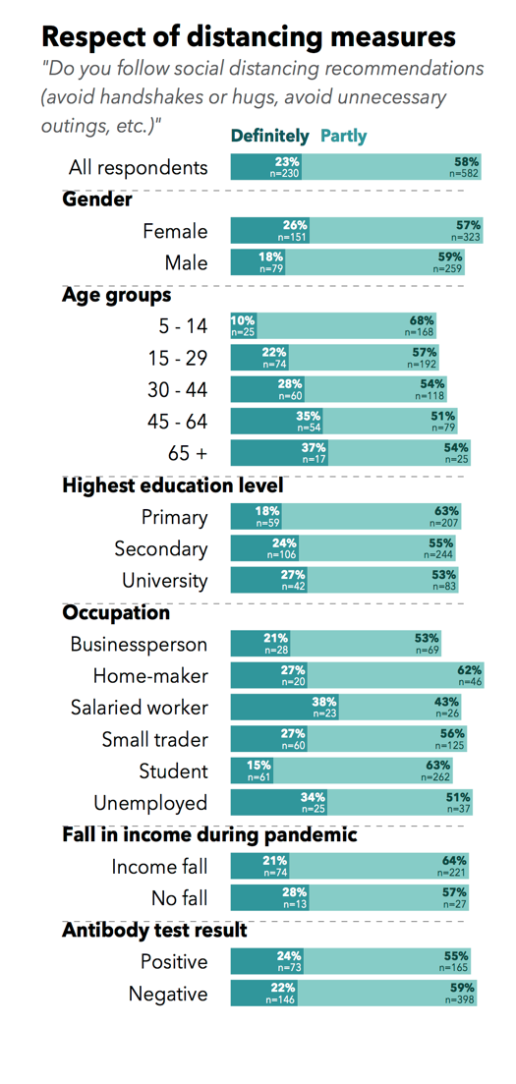

## Attitudes towards COVID-19

Participants’ attitudes towards the COVID-19 pandemic were noteworthy: around 825 (82%) reported fear of contamination (Figure 11), but only 23% said they fully followed the rules of physical distancing (Figure 12). Nearly half of the participants believed that people with COVID-19 are stigmatized, and 7% reported that they would conceal their illness to avoid this stigma.

Figure 11: Responses to questions on attitudes towards COVID-19

Figure 12: Responses to question on the respect of distancing measures

# Conclusions

Between March and November 26, 2020, SARS-CoV-2 appears to have circulated quite broadly in the city of Yaoundé, affecting about one third of the population in the *Cité Verte* district. However, more than 60% of those exposed had no symptoms, confirming that the largely asymptomatic nature of infections within this community.

The rate of seroprevalence observed, while similar to recent findings in other African settings, is quite high compared to results from other regions.

Considering IgM prevalence as a surrogate of recent infection (IgM response appearing between 5 and 12 days after symptoms onset), an overall low seroprevalence (3.4%) was found in this township, supporting rapid disappearance of this biomarker and its limited utility in monitoring SARS-CoV-2 infection.

Evidence from our findings shows that the most exposed groups in the community entail men, obese, and people living in crowded households. The differences in geographical distribution in the district appear to be driven by the density of households; in large households, physical distancing is more challenging.

Regarding health seeking behaviours, our report suggests some substantial health service disruptions during the pandemic period. Importantly, a certain number of respondents (15%) had difficulties in paying for healthcare services for acute or chronic conditions during the first phase of the pandemic, suggesting the need for in-depth investigation on the impact of COVID-19 on the health system in Cameroon. This is particularly important as COVID-19, appears as a source of significant disruption to household activities and incomes (85% reporting reduction of income).

Social and family activities were also significantly disrupted, leading to certain situations of conflict and stress, including violence. This is concerning as reduction in social and working activities has been described as a trigger for domestic violence exacerbated by confinement and experienced disproportionally by vulnerable groups.

# Bibliography

1. Lu H, Stratton CW, Tang Y. Outbreak of pneumonia of unknown etiology in Wuhan, China: The mystery and the miracle. *J Med Virol*. 2020;92(4):401-402. doi:10.1002/jmv.25678

2. World Health Organization. Weekly epidemiological update - 1 December 2020. Accessed December 8, 2020. https://www.who.int/publications/m/item/weekly-epidemiological-update---1-december-2020

3. AFP. WHO warns Africa is ill-equipped to deal with coronavirus due to “weaker health systems.” TheJournal.ie. Accessed December 8, 2020. https://www.thejournal.ie/world-health-organisation-african-coronavirus-5017867-Feb2020/

4. Umviligihozo G, Mupfumi L, Sonela N, et al. Sub-Saharan Africa preparedness and response to the COVID-19 pandemic: A perspective of early career African scientists. *Wellcome Open Res*. 2020;5. doi:10.12688/wellcomeopenres.16070.2

5. Stringhini S, Wisniak A, Piumatti G, et al. Seroprevalence of anti-SARS-CoV-2 IgG antibodies in Geneva, Switzerland (SEROCoV-POP): a population-based study. *The Lancet*. 2020;396(10247):313-319. doi:10.1016/S0140-6736(20)31304-0

6. Dortet L, Ronat J-B, Vauloup-Fellous C, et al. Evaluating Ten Commercially-Available SARS-CoV-2 Rapid Serological Tests Using the STARD (Standards for Reporting of Diagnostic Accuracy Studies) Method. *J Clin Microbiol*. Published online November 25, 2020. doi:10.1128/JCM.02342-20

7. Chazai Partners. *Recueil Des Mesures Prises Par Le Gouvernement Camerounais Dans Le Cadre de La Lutte Contre La COVID-19*. Accessed December 8, 2020. https://www.chazai-partners.com/wp-content/uploads/2020/05/Chazai-Partners-Recueil-des-mesures-prises-par-le-gouvernement-Camerounais-dans-la-lutte-contre-la-COVID-19-29-05-20.pdf

8. *Enquête Démographique et de Santé Du Cameroun 2018*. Institut National de la Statistique/INS et ICF

9. Rogan WJ, Gladen B. Estimating prevalence from the results of a screening test. *Am J Epidemiol*. 1978;107(1):71-76. doi:10.1093/oxfordjournals.aje.a112510

10. Batra R, Olivieri LG, Rubin D, et al. A comparative evaluation between the Abbott PanbioTM COVID-19 IgG/IgM rapid test device and Abbott ArchitectTM SARS CoV-2 IgG assay. *J Clin Virol*. 2020;132:104645. doi:10.1016/j.jcv.2020.104645

11. Shu H, Wang S, Ruan S, et al. Dynamic Changes of Antibodies to SARS-CoV-2 in COVID-19 Patients at Early Stage of Outbreak. *Virol Sin*. Published online July 27, 2020. doi:10.1007/s12250-020-00268-5

12. Lang Z, Reiczigel J. Confidence limits for prevalence of disease adjusted for estimated sensitivity and specificity. *Prev Vet Med*. 2014;113(1):13-22. doi:10.1016/j.prevetmed.2013.09.015

13. Santé O mondiale de la. Surveillance de la santé publique dans le contexte de la COVID-19 : orientations provisoires, 7 août 2020. Published online 2020. Accessed December 29, 2020. https://apps.who.int/iris/handle/10665/333903

14. Bates D, Mächler M, Bolker B, Walker S. Fitting Linear Mixed-Effects Models Using **lme4**. *J Stat Softw*. 2015;67(1). doi:10.18637/jss.v067.i01

15. Andri et mult. al. *{DescTools}: Tools for Descriptive Statistics*.; 2020. https://cran.r-project.org/package=DescTools

16. Wickham H, Averick M, Bryan J, et al. Welcome to the Tidyverse. *J Open Source Softw*. 2019;4(43):1686. doi:10.21105/joss.01686

24. Nzoghe AM, Essone PN, Leboueny M, Siawaya ACM, Bongho EC, Ndjindji OM, Houechenou RMA, aGNANDJI st, Siawaya JFD. . Evidence and implications of pre-existing humoral cross-reactive immunity to SARS-CoV-2. Immunity, Inflammation and disease. December 15, 2020. <https://doi.org/10.1002/iid3.367>

25 Iyer AS, Jones FK, Nodoushani A, Kelly M, Becker M, Slater D et al. Persistence and decay of human antibody responses to the receptor binding domain of SARS-CoV-2 spike protein in COVID-19 patients. Sci. Immunol. 2020.doi :10.1126/sciimmunol.abe0367 (2020).

26. [Gupta](https://www.ncbi.nlm.nih.gov/pubmed/?term=Gupta%20AK%5BAuthor%5D&cauthor=true&cauthor_uid=33253975) AK, Nethan ST, Mehrotra R. Tobacco use as a well-recognized cause of severe COVID-19 manifestations. [Respir Med](https://www.ncbi.nlm.nih.gov/pmc/articles/PMC7674071/). 2021 Jan; 176: 106233. Published online 2020 Nov 19. doi: [10.1016/j.rmed.2020.106233](https://dx.doi.org/10.1016%2Fj.rmed.2020.106233)

27. Adela N, Nkengazong L, Ambe LA, Ebogo JT, Mba FM, Goni HO, et al. (2020) Knowledge, attitudes, practices of/towards COVID 19 preventive measures and symptoms: A cross sectional study during the exponential rise of the outbreak in Cameroon. PLoS Negl Trop Dis 14(9): e0008700. <https://doi.org/10.1371/journal>. pntd.0008700

28. Evans ML, Lindauer M, Farrell ME. A Pandemic within a Pandemic — Intimate Partner Violence during Covid-19. NEJM 2020 383;24

